**Homework**

**Simple Linear Regression**

**Answer 1**

(a) GPA in High School

(b) The target variable is continuous.

(c) The predictor of the target variable could be “attendance in the classroom”.

(d) Yes, a linear model is reasonable and the sign of the slope should be positive since it is directly proportional.

**

From the graph the predicted value at x=2.5 is 8.

**Answer 3**

$y=y_{o}e^{-at}$

$$\log\left(y\right)=\log\left(y_{o}\right)-at log⁡(e)$$

$$\log\left(y\right)=\log\left(y_{o}\right)-at ln(e)$$

$$\log\left(y\right)=\log\left(y_{o}\right)-at$$

Linear Form : y= constant – gradient * x

$\log\left(y\right)=\log\left(y_{o}\right)-at$

Using Least Square solutions :

$a (gradient)=\frac{n\sum_{i=1}^{n}{t_{i}}\ln{y_{i}}-\sum_{i=1}^{n}{t_{i}\sum_{i=1}^{n}{lny_{i}}}}{n\sum_{i=1}^{n}{t_{i}^{2}}-{\left(\sum_{i=1}^{n}{t_{i}}\right)}^{2}}$

$$\log\left(y_{o}\right)=\frac{\sum_{i=1}^{n}{lny_{i}\sum_{i=1}^{n}{t^{2}-\sum_{i=1}^{n}{t_{i}\sum_{i=1}^{n}{t_{i}\ln{y_{i}}}}}}}{n\sum_{i=1}^{n}{t_{i}^{2}}-{(\sum_{i=1}^{n}{t_{i}})}^{2}}$$

(c)

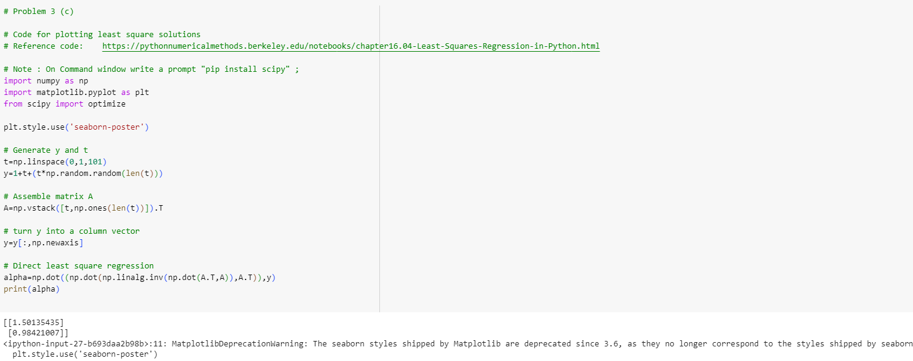

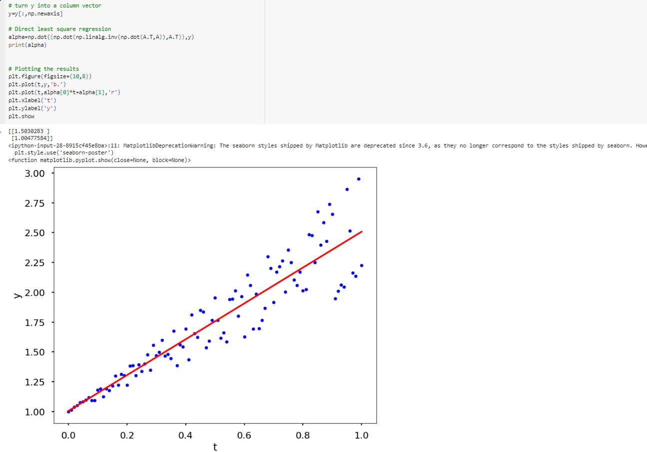

**Answer -4**

1. RSS (β) = $\sum_{i=1}^{n}{{(y_{i}-\hat{y_{i}})}^{2}}$ where, n is the number of data points.

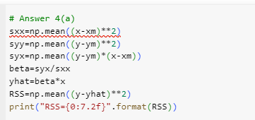

${Rss}_{min}=\left(1-r_{xy}^{2}\right)*S_{yy}$

where $r_{xy}=\frac{S_{yx}}{\sqrt{S_{xx}S_{yy}}}$

